School Management System

**Client Need :**

The school requires a simple database system to manage students, teachers, classes, subjects, and grades.  
The system should allow storing, updating, and retrieving data, with support for basic queries and user access control.

**1. Users**

| **User Type** |  | **Description** |
| --- | --- | --- |
| **Admin** |  | Manages the system: can add/edit students, teachers, classes, subjects, and grades. |
| **Teacher** |  | Can view students and enter grades for the subjects they teach. |
| Student |  | Can view their own grades only . |

**2. Entities**

| **Entity** |  |  | **Description** |
| --- | --- | --- | --- |
| **Student** |  |  | Stores student information such as name, gender, birthdate, and class assignment. |
| **Teacher** |  |  | Stores teacher details and the subject they teach. |
| **Class** |  |  | Represents a school class, students belong to classes. |
| **Subject** |  |  | Represents a subject taught in the school. |
| **Grade** |  |  | Records the grades assigned to students for each subject. |

**3.ERD**

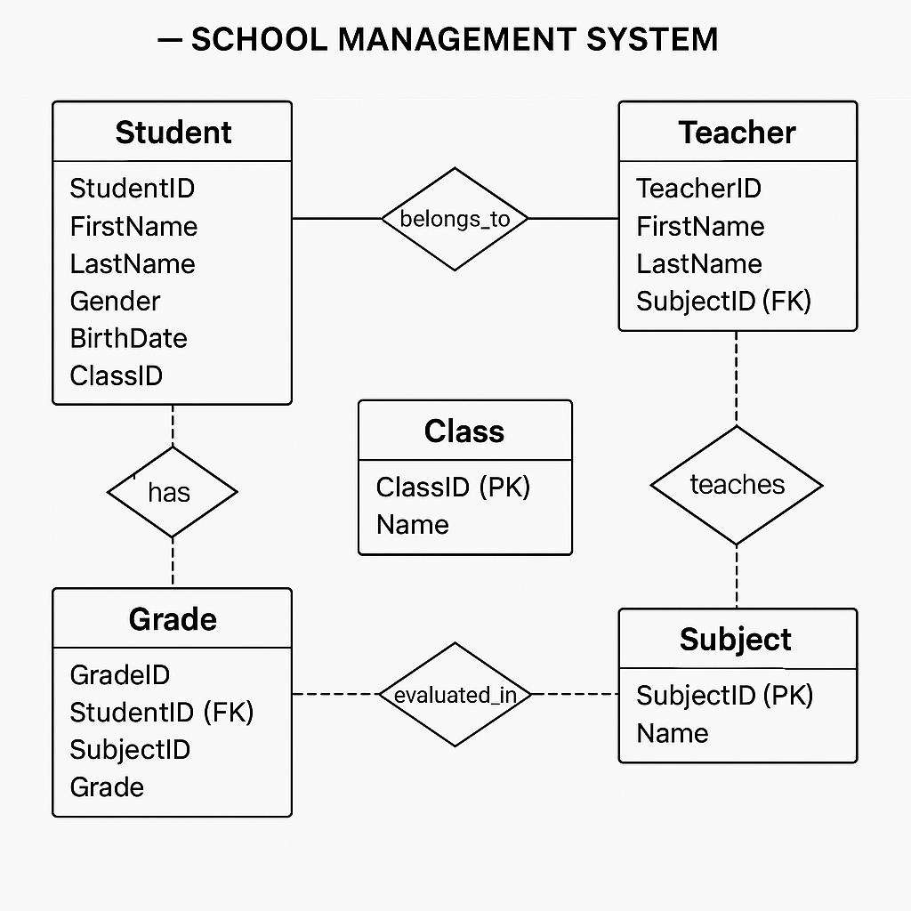

**4.Mapping**

| Entity | Attributes

| Student -> | StudentID (PK), FirstName, LastName, Gender, BirthDate, ClassID (FK)

| Teacher -> | TeacherID (PK), FirstName, LastName, SubjectID (FK)

| Class -> | ClassID (PK), Name

| Subject -> | SubjectID (PK), Name

| Grade -> | GradeID (PK), StudentID (FK), SubjectID (FK), Grade

Primary Keys (PK):

- Classes(ClassID)

- Students(StudentID)

- Teachers(TeacherID)

- Subjects(SubjectID)

- Grades(GradeID)

Foreign Keys (FK):

- Students.ClassID -> Classes.ClassID

- Teachers.SubjectID -> Subjects.SubjectID

- Grades.StudentID -> Students.StudentID

- Grades.SubjectID -> Subjects.SubjectID

- Relationships

1. Student → Class → *Each student belongs to one class.* (1 to Many)

2. Teacher → Subject→ *Each teacher teaches one subject.* (1 to Many)

3. Student → Grade → *Each student receives grades in subjects.* (Many to Many)

4. Subject → Grade→ *Each grade is associated with a subject.* (1 to Many)

**5. Normalization**

1NF**

| **Student** | **Teacher** | **Class** | **Subject** | **Grade** |

| StudentID (PK) | TeacherID (PK) | ClassID (PK) | SubjectID (PK) | GradeID (PK) |

| FirstName | FirstName | Name | Name | StudentID (FK) |

| LastName | LastName | | | SubjectID (FK) |

| Gender | SubjectID (FK) | | | Grade |

2NF**

| **Student_Class** |

|------------------|

| StudentID (FK) |

| ClassID (FK) |

3NF**

| **Teacher_Subject** |

|--------------------|

| TeacherID (FK) |

| SubjectID (FK) |